Module 3: Database Integration
HANDS -ON 3 : Advanced SQL — Subqueries, Views & Transactions

Task 1: Subqueries
35. Find students enrolled in more courses than the average number of enrollments per student.
select
s.student_id,
concat(s.first_name,' ',s.last_name) as student_name,
count(e.course_id) as total_courses
from students s
join enrollments e
on s.student_id = e.student_id
group by s.student_id, s.first_name, s.last_name
having count(e.course_id) >
(
select avg(course_count)
from
(
select count(course_id) as course_count
from enrollments
group by student_id
) as avg_table
);
Output:
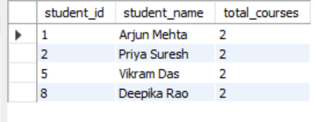
36. List courses in which all enrolled students have received a grade of 'A'.
select c.course_name, c.course_code
from courses c
where not exists
(
select 1
from enrollments e
where e.course_id = c.course_id
and e.grade <> 'A'
);
output:
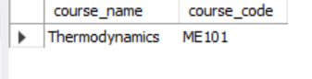
37. Find the professor with the highest salary in each department.
select
p.prof_name,
d.dept_name,
p.salary
from professors p
join departments d
on p.department_id = d.department_id
where p.salary =
(
select max(p2.salary)
from professors p2
where p2.department_id = p.department_id
);
Ouptut:
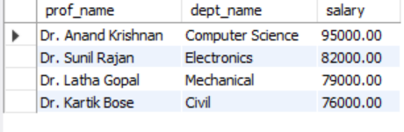
38. Calculate department average salary using derived table and filter above 85000.
select *
from
(
select
d.dept_name,
avg(p.salary) as average_salary
from departments d
join professors p
on d.department_id = p.department_id
group by d.department_id, d.dept_name
) as dept_salary
where average_salary > 85000;

Output:
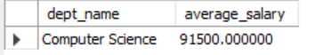

Task 2: Creating and Using Views
39. Create view vw_student_enrollment_summary.
create view vw_student_enrollment_summary as
select
concat(s.first_name,' ',s.last_name) as student_name,
d.dept_name,
count(e.course_id) as total_courses,
round(avg(
case
when e.grade='A' then 4
when e.grade='B' then 3
when e.grade='C' then 2
when e.grade='D' then 1
when e.grade='F' then 0
end
),2) as gpa
from students s
join departments d
on s.department_id=d.department_id
left join enrollments e
on s.student_id=e.student_id
group by s.student_id,d.dept_name;
select *
from vw_student_enrollment_summary;
Ouptut:
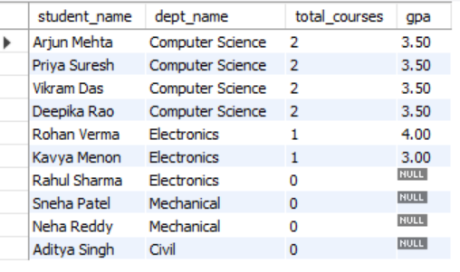
40. Create view vw_course_stats.
create view vw_course_stats as
select
c.course_name,
c.course_code,
count(e.student_id) as total_enrollments,
round(avg(
case
when e.grade='A' then 4
when e.grade='B' then 3
when e.grade='C' then 2
when e.grade='D' then 1
when e.grade='F' then 0
end
),2) as avg_gpa
from courses c
left join enrollments e
on c.course_id=e.course_id
group by c.course_id,c.course_name,c.course_code;
select *
from vw_course_stats;
Output:
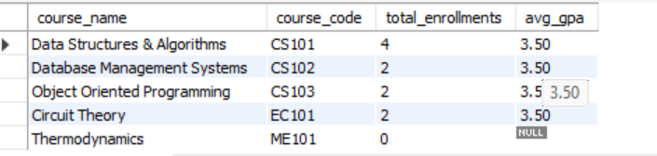

41. Find students with GPA above 3.0.
select *
from vw_student_enrollment_summary
where gpa > 3.0;

Output:
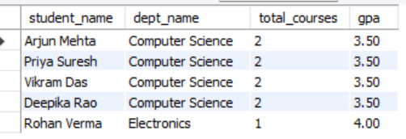

42. Attempt update through vw_student_enrollment_summary.
update vw_student_enrollment_summary
set gpa = 4.0
where student_name = 'Arjun Mehta';
43. Drop views and recreate vw_student_enrollment_summary with CHECK OPTION.
drop view vw_student_enrollment_summary;
drop view vw_course_stats;
create view vw_student_enrollment_summary as
select
student_id,
first_name,
last_name,
email,
department_id,
enrollment_year
from students
where enrollment_year >= 2022
with check option;
select *
from vw_student_enrollment_summary;
Output:
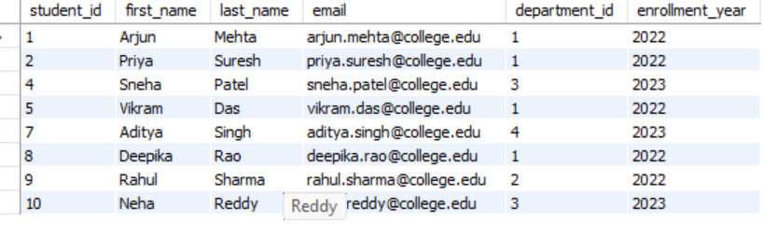
Task 3: Stored Procedures and Transactions
44. Create procedure sp_enroll_student.
delimiter $$
create procedure sp_enroll_student(
in p_student_id int,
in p_course_id int,
in p_enrollment_date date
)
begin
if exists
(
select *
from enrollments
where student_id = p_student_id
and course_id = p_course_id
)
then
signal sqlstate '45000'
set message_text = 'Student already enrolled in this course';
else
insert into enrollments
(student_id, course_id, enrollment_date)
values
(p_student_id, p_course_id, p_enrollment_date);
end if;
end $$
delimiter ;
call sp_enroll_student(9,1,'2026-06-26');
Output:
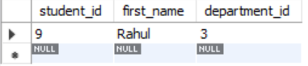

45. Create procedure sp_transfer_student.
create table department_transfer_log (
log_id int auto_increment primary key,
student_id int,
old_department_id int,
new_department_id int,
transfer_date date
);
delimiter $$
create procedure sp_transfer_student(
in p_student_id int,
in p_new_department_id int
)
begin
declare old_dept int;
start transaction;
select department_id
into old_dept
from students
where student_id = p_student_id;
update students
set department_id = p_new_department_id
where student_id = p_student_id;
insert into department_transfer_log
(student_id, old_department_id, new_department_id, transfer_date)
values
(p_student_id, old_dept, p_new_department_id, curdate());
commit;
end $$
delimiter ;
call sp_transfer_student(9,3);
Output:
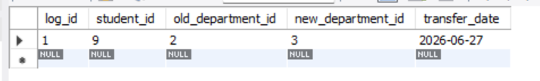

46. Test transaction rollback.
select student_id, first_name, department_id
from students
where student_id = 9;
select * from department_transfer_log;
47. Use SAVEPOINT transaction.
start transaction;
insert into enrollments
(student_id, course_id, enrollment_date)
values
(10,1,'2026-06-26');
savepoint first_insert;
insert into enrollments
(student_id, course_id, enrollment_date)
values
(999,1,'2026-06-26');
rollback to first_insert;
commit;
select *
from enrollments
where student_id = 10;
Output:
